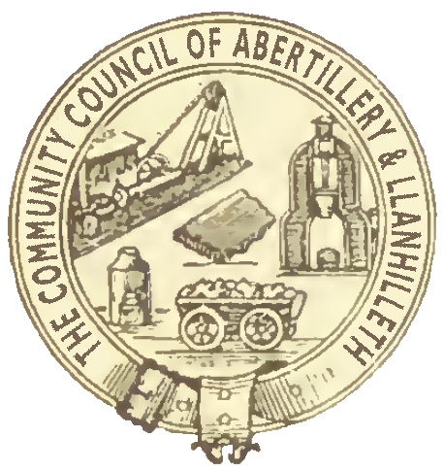

Abertillery and Llanhilleth Community Council (ALCC)

What are Council Grants?

- The purpose of Council Grants is to help local communities and organisations improve the well-being of local people. A Council Grant will only be made if there is a clear economic, social or environmental well-being benefit to residents of the ALCC area.
- The organisation must usually be based in or operate substantially in the Abertillery and Llanhilleth Community Council area, and the majority of the members of the organisation, or those it serves, should live in the Abertillery and Llanhilleth Community Council area.
- If the organisation is based outside the Abertillery and Llanhilleth Community Council area, evidence must be given of how (and how many) people from the ALCC area benefit from the work of the organisation.
- The Council places a high value on voluntary and community service.
- The Council will not make a grant to professional or commercial clubs or organisations, companies, businesses or other enterprises which aim to make a profit. The Council will only make grants to enterprises if they are not for profit and if any surplus generated by the enterprise is reinvested into improving local communities or local community facilities.
- Organisations such as sports clubs or parks which have become companies in order to manage or run community facilities under Community Asset Transfers may be considered for Council Grants.
- The Council will not give any funding to national charities, unless they can demonstrate clearly how that funding will benefit residents and service users in the ALCC area.
- Council Grants will not be given to groups to pay for ongoing running costs (e.g. insurance, water, gas and other utility supplies etc) unless in exceptional circumstances.
- The Council wishes to spend its limited grants budget to help as many people and communities as possible in the ALCC area. The Council will not therefore give financial support to the same organisation in two consecutive years unless in exceptional circumstances.
- The Council will not give a grant of more than £500 to one organisation unless in exceptional circumstances.

How does the Council Grants process work?

- All Council Grant applications must be made using the Council Grant application form. The Council will not consider any grant applications which are not on the required form or which do not contain the required details (e.g. specific amounts and outcomes).
- The Finance and Grants Committee will consider all grant applications in detail and make recommendations to the full Council.
- The Finance and Grants Committee and the Council will consider grant applications no more than four times a year; intended to be in April, June, November and January. Any applications submitted after a relevant deadline will be held over and not considered until the following meeting.
- A representative of the applicant organisation may be required to attend a meeting of the Council / Finance / Grants Committee in order to outline the application / project and answer questions.
- Any grant made by the Council must be publicised appropriately by the receiving organisation (e.g. on its website, social media pages or posters/programmes). If appropriate publicity is not given, the organisation concerned will receive no further funding from ALCC.
- The Council may at any time require any and all such evidence it decides that a Council Grant given previously has been spent in the manner for which it was intended.

