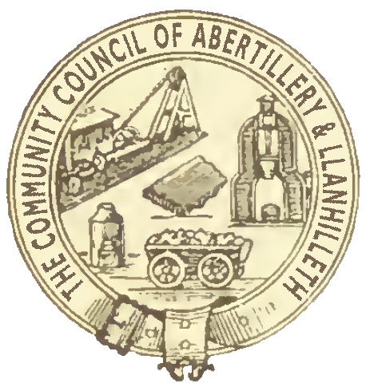

Abertillery and Llanhilleth Community Council (ALCC)

Ward Grant Application
(see criteria and process attached before applying)

Name and Address of group, organisation or project:

Group Contact name: ………………………………………………………………….….

Role in the group: ……………………………………………………………….…….

Telephone number: ………………………………………………………………….….

Email: ………………………………………………………………..…….

What are the aims of the group or project? …………………………………………..
……………………………………………………………………………………………………………………………………………………………………………………………………

How does the group / project benefit the Abertillery and Llanhilleth area or its residents? …………………………………………………………………………………..
……………………………………………………………………………………………………………………………………………………………………………………………………

Approx number of beneficiaries ………………………………………………………..

Is the organisation a: Charity/community group/sports club/company/not for profit business/other (explain and provide evidence) ………………………………………………………………………………………………………………………………………………………………………………………………

Amount requested: …………………………………………………………

Payee name: ………………………………..………………………..

Name of Councillor making the application:

Print Name: …………….……………………….…………………………

Signed: ..………………………………………………………………

Date: …..……………………

Please return this form with any relevant supporting documents (group constitution,
financial statements, letters of support etc.) to: Town Clerk, Abertillery and Llanhilleth Community Council, Mitre Street, Abertillery, NP13 1AE or to clerk.alcc@gmail.com

