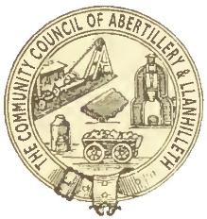
ABERTILLERY AND LLANHILLETH COMMUNITY COUNCIL

SURVEY

Do you know Abertillery and Llanhilleth has a community council? Yes / No

Do you know what the community council does? Yes / No

Do you know where the community council office is? Yes / No

What do you think the community council should do? For example:

- Better facilities for young people
- Better local community events
- Better parks and leisure facilities
- Cleaner streets
- Towns “in bloom”

Please say what you would like the community council to do

………………………………………………………………………………………………..

Do you know that most households (however many people live in them) pay less than £17 per year for the community council (this is called the precept)?

Yes / No

Do you think the community council should do more for the communities of Abertillery and Llanhilleth and increase the precept in order to do so?

Yes / No

Name
Where do you live? (ward / area)
Can we contact you to discuss further? Yes / No
Email address / phone number?

Please complete this form and return it by post to The Clerk, Abertillery and Llanhilleth Community Council, Council Offices, Mitre Street, Abertillery, NP13 1AE - or complete it and return it by email to clerk.ALCC@gmail.com

