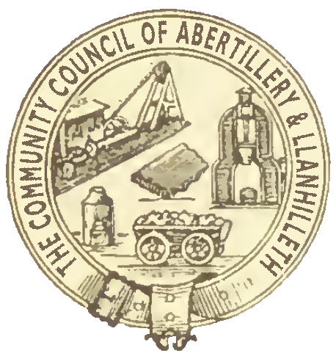
CO-OPTED COUNCILLOR PERSON SPECIFICATION
Personal Attributes
- Sound knowledge and understanding of local affairs and the local community.
- Forward-thinking
- Can bring a new skill, expertise or key local knowledge to the Council.
Experience, Skills, Knowledge and Ability
- Ability to listen constructively
- A good team player
- Ability to pick up and run with a variety of projects
- Solid interest in local matters
- Ability and willingness to represent the Council and their community
- Good interpersonal skills and able to contribute opinions at meetings whilst willing to see others’ views and accept majority decisions.
- Ability to communicate succinctly and clearly.
- Ability and willingness to work closely with other members and to maintain good working relationships with all members and staff.
- Ability and willingness to work with the Council’s partners (e.g., voluntary groups, other Community Councils, principal authority, charities).
- Ability and willingness to undertake induction training and other relevant training.
- Experience of working or being a member in a local authority or other public body
- Experience of working with voluntary and or local community / interest groups
- Basic knowledge of legal issues relating to town and Community Councils or local authorities
Circumstances
- Ability and willingness to attend meetings of the Council (or meetings of other local authorities and local bodies) at any time of day, and events in the evening and at weekends.

To: The Clerk
Abertillery & Llanhilleth Community Council
Council Offices
Mitre Street
Abertillery
NP13 1AE

Tel: 01495 217323
email: clerk.alcc@gmail.com

APPLICATION FOR THE ROLE OF COMMUNITY COUNCILLOR
ON ABERTILLERY AND LLANHILLETH COMMUNITY COUNCIL
Full name
Home address
incl. postcode
Home telephone number
Mobile number
Email
It is a condition of being a Community Councillor for Abertillery and Llanhilleth that your phone number and email address (an official email address will be supplied) be made public via notice boards and website.
LEGAL QUALIFICATIONS FOR BEING A COMMUNITY COUNCILLOR QUALIFICATIONS

(To qualify you must be able to answer ‘Yes’ to both of the questions below)
Are you a British citizen, a Commonwealth citizen or a citizen of a European Union country? | Yes / No
Are you aged 18 or over? | Yes / No

(To qualify you must be able to answer ‘Yes’ to at least one of the questions below)
Are you on the electoral register for a ward within the Abertillery & Llanhilleth Community Council area? | Yes / No
Have you lived either in the Abertillery & Llanhilleth Community Council area, or within three miles of its boundary, for at least a year? | Yes / No
Have you been the owner or tenant of land in the Abertillery & Llanhilleth Community Council area for at least a year? | Yes / No
Have you had your only or main place of work in the Abertillery & Llanhilleth Community Council area for at least a year? | Yes / No

DISQUALIFICATIONS

(You must be able to answer No to all of the questions below to be eligible to serve as a councillor)
Are you the subject of a bankruptcy restrictions order or interim order? | Yes / No
Have you within the last five years been convicted of an offence in the UK, the  Channel Islands or the Isle of Man which resulted in a sentence of imprisonment (whether suspended or not) for a period of three months or more without the option of a fine? | Yes / No
Are you disqualified by order of a court from being a member of a local authority? | Yes / No

With reference to the Person Specification, please tell us something about the skills that you feel you will bring to the Council plus details of, for example, professional qualifications and financial or project management expertise.

Please tell us something about the life experience that you will bring to the Council. Examples may include previous local government experience, work in the voluntary or charitable sector, business or trade union experience etc

Please outline why you are interested in being a community councillor.

Your signature:

Date:

Email your completed application form to clerk@abertilleryandllanhilleth-wcc.gov.uk

Alternatively, you can post (or hand-deliver) the completed form to The Clerk, Abertillery & Llanhilleth Community Council, Council Offices, Mitre Street, Abertillery, NP13 1AE

