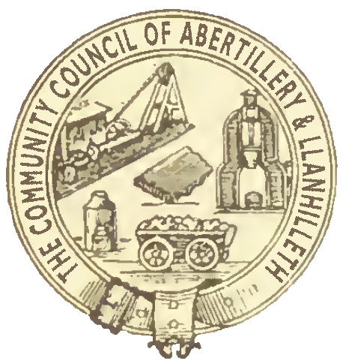

Abertillery and Llanhilleth Community Council (ALCC)

What are Solar Farm Grants?

- The Solar Farm Grant is a grant given by CIC Community Green Energy to Abertillery and Llanhilleth Community Council (ALCC).
- CIC awards an amount to ALCC depending on the amount of electricity generated at the Solar Farm at Hafod-y-Dafal on an annual basis.
- The grant is not for the Council’s use.
- It is for the Council (as the elected representative body closest to local communities) to decide how to allocate the grant to local community projects, groups or organisations.
- CIC requires the funding to be allocated to community projects which are sustainable, have a lasting legacy, are environmental in nature and are for wide community benefit.
- CIC and ALCC require evidence (regular reports and photos) that any money granted has been spent in the manner envisaged and that the stated community benefits have been achieved.
- Any grant from the Council (including Solar Farm Grants) must help local communities and organisations improve the well-being of local people.
- A Solar Farm Grant will only be made if there is a clear economic, social or environmental well-being benefit to residents of the ALCC area.
- The organisation involved must usually be based in or operate substantially in the Abertillery and Llanhilleth Community Council area, and the majority of the members of the organisation, or those it serves, should live in the Abertillery and Llanhilleth Community Council area.
- If the organisation is based outside the Abertillery and Llanhilleth Community Council area, evidence must be given of how (and how many) people from the ALCC area benefit from the work of the organisation.
- The Council places a high value on voluntary and community service.
- The Council will not make a grant to professional or commercial clubs or organisations, companies, businesses or other enterprises which aim to make a profit. The Council will only make grants to enterprises if they are not for profit and if any surplus generated by the enterprise is reinvested into improving local communities or local community facilities.
- Organisations such as sports clubs or parks which have become companies in order to manage or run community facilities under Community Asset Transfers may be considered for Solar Farm Grants.
- Solar Farm Grants will not be used to help fund national charities or organisations (where the principal benefit is not to residents of the ALCC area) under any circumstances.
- Solar Farm Grants will not be given to groups to pay for ongoing running costs (e.g. insurance, water, gas and other utility supplies etc) unless in exceptional circumstances.
- Solar Farm Grants must help as many people and communities as possible in the ALCC area.
- The Council will not give Solar Farm Grants to the same organisation(s) within five consecutive years unless in exceptional circumstances.
- The minimum Solar Farm Grant to be given by ALCC is £5,000 (if that amount is available to ALCC from CIC).
- The maximum Solar Farm Grant to be given by ALCC is £35,000 (if that amount is available to ALCC from CIC).
- The Solar Farm Grant 2021 will go to projects which:

- involve a lasting legacy and tangible benefits to local communities
- contribute to sustainability
- are in themselves sustainable. The organisation must be able to run the project/ building/facility itself, after the Solar Farm Grant has ended, without further revenue support from ALCC
- involve links with local schools
- promote opportunities for local volunteering
- deliver environmental improvements
- promote links between different areas or communities within the ALCC area
- meet the well-being goals set out in the Well-being of Future Generations (Wales) Act 2015.

How does the Solar Farm Grants process work?

- CIC informs ALCC of how much funding is available for the following year.
- CIC asks ALCC to decide how to allocate that funding.
- ALCC decides how to allocate that funding and seeks agreement from CIC.
- If CIC agrees, it pays the funding to ALCC.
- ALCC distributes the funding, monitors the spending and reports back to CIC.
- This document describing the process and criteria, and the application form agreed by the Council, will be issued to all ALCC Councillors and placed on the Council’s website
- All Solar Farm Grant applications must be made using the Solar Farm Grant application form. The Council will not consider any applications which are not on the Solar Farm Grant application form or which do not contain the required details.
- Interested groups and organisations must supply the completed form and all relevant supporting documents to the Councillor who is supporting their application by Friday 24th September.
- The forms and supporting documents will be supplied to the members of the Solar Farm Grants Working Group (SFGWG) as soon as possible after receipt.
- The SFGWG will meet as soon as possible after the end date for applications .
- A suitable representative of the organisation (e.g. Chairman, Secretary or Treasurer) must attend the SFGWG as requested to present the application and answer questions.
- The SFGWG will consider all the applications submitted and make recommendations to the Council on 27 October, about which application(s) should be approved by the Council.
- Cheques will be issued as soon as possible after that date to the successful organisations.
- The organisation must undertake in writing to provide quarterly reports back, including photographs or other written evidence, to demonstrate progress.
- The Council may at any time require any and all such evidence it decides that a Solar Farm Grant given previously has been spent in the manner for which it was intended. If insufficient progress is made or insufficient evidence is given, the Council may reclaim all or part of the funding granted and return this to CIC.
- Any grant must be publicised appropriately by the receiving organisation (e.g. on its website, social media pages or posters/programmes). If appropriate publicity is not given, the organisation concerned will receive no further funding from ALCC (or CIC).

