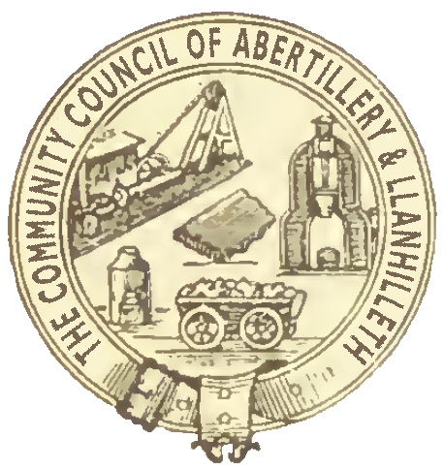

Abertillery and Llanhilleth Community Council (ALCC)

What are Solar Farm Grants – 2025

1. The Solar Farm Grant is a grant given by Lightsource BP, the owners of the solar farm, to Abertillery and Llanhilleth Community Council (ALCC).
2. They award an amount to ALCC depending on the amount of electricity generated at the Solar Farm at Hafod-y-Dafal on an annual basis.
3. The grant is not for the Council’s use. It is for Community Organisations; the Council only administer the process.
4. It is for the Council (as the elected representative body closest to local communities) to decide how to allocate the grant to local community projects, groups or organisations.
5. The funding to be allocated to community projects which are sustainable, have a lasting legacy, so the benefits should be shown over a number of years, are environmental in nature and are for wide community benefit.
6. ALCC require evidence (regular reports and photos) that any money granted has been spent in the manner envisaged and that the stated community benefits have been achieved.
7. Any grant from the Council (including Solar Farm Grants) must help local communities and organisations improve the well-being of local people. The well-being can be for health, mental, environmental, for any age group and social. There is no strict definition.

Criteria for awarding the grants

1. The organisation involved must usually be based in or operate substantially in the Abertillery and Llanhilleth Community Council area, and the majority of the members of the organisation, or those it serves, should live in the Abertillery and Llanhilleth Community Council area.
2. If the organisation is based outside the Abertillery and Llanhilleth Community Council area, evidence must be given of how (and how many) people from the ALCC area benefit from the work of the organisation.
3. The Council places a high value on voluntary and community service.
4. The Council will not make a grant to professional or commercial clubs or organisations, companies, businesses or other enterprises which aim to make a profit. The Council will only make grants to enterprises if they are not for profit and if any surplus generated by the enterprise is reinvested into improving local communities or local community facilities.
5. Organisations such as sports clubs or parks which have become companies in order to manage or run community facilities under Community Asset Transfers may be considered for Solar Farm Grants.
6. Solar Farm Grants will not be used to help fund national charities or organisations (where the principal benefit is not to residents of the ALCC area) under any circumstances.
7. Solar Farm Grants will not be given to groups to pay for ongoing running costs (e.g. insurance, water, gas and other utility supplies etc) unless in exceptional circumstances.
8. Solar Farm Grants must help as many people and communities as possible in the ALCC area.
9. The Council will not give Solar Farm Grants to the same organisation(s) within five consecutive years unless in exceptional circumstances.
10. The minimum Solar Farm Grant to be given by ALCC is £5,000
11. The maximum Solar Farm Grant to be given by ALCC is £35,000
12. The Solar Farm Grant 2025 will go to projects which:

* involve a lasting legacy and tangible benefits to local communities
* contribute to sustainability
* are in themselves sustainable. The organisation must be able to run the project/ building/facility itself, after the Solar Farm Grant has ended, without further revenue support from ALCC
* involve links with local schools
* promote opportunities for local volunteering
* deliver environmental improvements
* promote links between different areas or communities within the ALCC area
* meet the well-being goals set out in the Well-being of Future Generations (Wales) Act 2015

How does the Solar Farm Grants process work?

1. Lightsource (BP) informs ALCC of how much funding is available for the following year.
2. Lightsource (BP) asks ALCC to decide how to allocate that funding.
3. ALCC decides how to allocate that funding and seeks agreement from Lightsource (BP).
4. If Lightsource (BP) agrees, it pays the funding to ALCC.
5. ALCC distributes the funding, monitors the spending and reports back to Lightsource (BP).
6. This document describing the process and criteria, and the application form agreed by the Council, will be issued to all ALCC Councillors and placed on the Council’s website
7. All Solar Farm Grant applications must be made using the Solar Farm Grant application form. The Council will not consider any applications which are not on the Solar Farm Grant application form or which do not contain the required details.
8. Interested groups and organisations must supply the completed form and all relevant supporting documents to the Council by 31st July 2025
9. A suitable representative of the organisation (e.g. Chairman, Secretary or Treasurer) may attend the Council as requested to present the application and answer questions.
10. The Council will meet in September 2025, about which application(s) should be approved by the Council.
11. Payment will be issued as soon as possible after that date to the successful organisations.
12. The organisation must undertake in writing to provide quarterly reports back, including photographs or other written evidence, to demonstrate progress.
13. The Council may at any time require any and all such evidence it decides that a Solar Farm Grant given previously has been spent in the manner for which it was intended. If insufficient progress is made or insufficient evidence is given, the Council may reclaim all or part of the funding granted and return this to Lightsource (BP)
14. Any grant must be publicised appropriately by the receiving organisation (e.g. on its website, social media pages or posters/programmes). If appropriate publicity is not given, the organisation concerned will receive no further funding from ALCC (or Lightsource (BP).