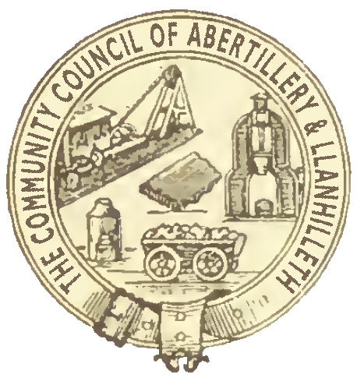

Abertillery and Llanhilleth Community Council (ALCC)

What are Ward Grants?

- Ward Grants are to help local communities and organisations improve the well-being of local people. A Ward Grant will only be made if there is a clear economic, social or environmental well-being benefit to residents of the ALCC area.
- The organisation must usually be based in, operate substantially in, or serve people mainly in the ward for which the Councillor concerned is responsible. Otherwise, it must be an organisation which serves people in the whole of the ALCC area.
- The Council places a high value on voluntary and community service.
- No Ward Grants will be made to professional or commercial clubs or organisations, companies, businesses or other enterprises which aim to make a profit. Ward Grants will only be made to enterprises if they are not for profit and if any surplus generated by the enterprise is reinvested into improving local communities or local community facilities.
- Organisations such as sports clubs or parks which have become companies in order to manage or run community facilities under Community Asset Transfers may be considered for Ward Grants.
- Ward Grants may not be used to fund national charities or organisations under any circumstances.

How does the Ward Grants process work?

- An ALCC Councillor may apply for ward grants to be given to groups or organisations based or located in their ward. They may also apply for ward grants for groups or organisations based or located outside their ward – if the group or organisation has a multi-ward or whole-area benefit (e.g. the Museum Trust, Hospice of the Valleys, choirs, bands, drama groups, sports clubs etc) (this list is not exhaustive).
- Councillors must declare any personal or prejudicial interests in ward grants under the Code of Conduct in the same way as any other matter or business.
- The total budget available will be £200 per year, per councillor, for this purpose.
- If a ward councillor’s £200 allocation has been spent and they then cease to be a councillor, that allocation will not be available again (to any new councillor for that ward) until the following financial year.
- The minimum Ward Grant will be £50. The maximum Ward Grant will be £200.
- All Ward Grant applications must be made by Councillors using the Ward Grant Application form and include the required details, prior to their consideration.
- All applications for Ward Grants will be considered by the Finance and Grants Committee.
- The Finance and Grants Committee will be able to approve (but not refuse) ward grant applications.
- The councillor making the application may be required to make the case for approval of the Ward Grant at the Finance and Grants Committee meeting.
- If the Finance and Grants Committee is minded to refuse a Ward Grant application, the application must be referred to the Council for a decision.
- The Finance and Grants Committee should consider Ward Grant applications no more than four times a year; intended to be in April, June, November and January. Any applications submitted after a relevant deadline will be held over and not considered until the following meeting.
- Any Ward Grant must be publicised appropriately by the receiving organisation (e.g. on its website, social media pages or posters/programmes). If appropriate publicity is not given, the organisation concerned will receive no further funding from ALCC.
- The Council may at any time require any and all such evidence it decides that a Ward Grant given previously has been spent in the manner for which it was intended.

This version was adopted at the Council meeting on 29 January 2020

